Objective:

This lab covers the basic concepts of binary trees, and then works through a series of practice problems with code in C++. Binary trees have an elegant recursive pointer structure, so they are a good way to learn recursive pointer algorithms. Thus it presents an over view of binary search trees and some problems along with their solutions

Binary Trees:

A binary tree is made of nodes, where each node contains a "left" pointer, a "right" pointer, and a data element. The "root" pointer points to the topmost node in the tree. The left and right pointers recursively point to smaller "subtrees" on either side. A null pointer represents a binary tree with no elements -- the empty tree. The formal recursive definition is: a binary tree is either empty (represented by a null pointer), or is made of a single node or at most two nodes, where the left and right pointers (recursive definition ahead) each point to a binary tree.

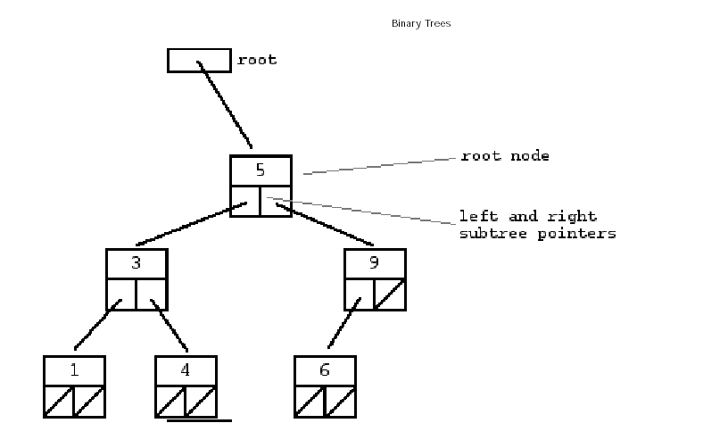
A "binary search tree" (BST) or "ordered binary tree" is a type of binary tree where the nodes are arranged in order: for each node, all elements in its left subtree are less-or-equal to the node (<=), and all the elements in its right subtree are greater than the node (>). The tree shown above is a binary search tree -- the "root" node is a 5, and its left subtree nodes (1, 3, 4) are <= 5, and its right subtree nodes (6, 9) are > 5. Recursively, each of the subtrees must also obey the binary search tree constraint: in the (1, 3, 4) subtree, the 3 is the root, the 1 <= 3 and 4 > 3. Watch out for the exact wording in the problems -- a "binary search tree" is different from a "binary tree".

The nodes at the bottom edge of the tree have empty subtrees and are called "leaf" nodes (1, 4, 6) while the others are "internal" nodes (3, 5, 9).

Basically, binary search trees are fast at insert and lookup

Construct a class BST that contains the following functions:

Question#1:

Insert a node into BST iteratively. The recursive code is as follows:

void insert(Node*& root, int value)
{
if(root == NULL)

{
Node* temp3 = new node;
temp3->data = value;
temp3->right = NULL;
temp3->left = NULL;
root = temp3;
}
else
{
if(value <= rootref->data)
{
insert(root->left, value);
}
else
{
insert(root->right, value);
}
}
}

Question#2:

Display the BST recursively using the following traversals:
- Inorder
- Preorder
- Postorder

Question #3:

Write a function to search for a particular element in BST recursively or iteratively

Question #4:

Write a function that would delete a particular element from the BST using the logic explained below.

How are nodes in BSTs deleted?

A BST is an arranged data structure such that all the nodes to the right of a node are greater than that particular node and all the nodes to the left of a node are smaller than that particular node. However, when a particular node is deleted then the order of the nodes has to be changed such that the structure is maintained.

When deleting a node from a BST there are three cases to be considered:
- Element is a leaf
- Element is a node of degree 1
- Element is a node of degree 2

- The first case is pretty simple. Delete the node to be deleted, if it is a right child set the right pointer of the child to NULL, else set the left pointer to be NULL

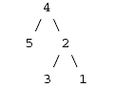

So in this case if 1 is to be deleted, then the right pointer of the node labeled 2 is set to NULL.
- The second case is also simple, the node to be deleted is deleted and the child of this node is put in as the child of the deleted node takes place of the deleted node.

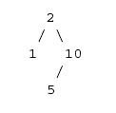

Now in this case 10 is a node of degree 1 (that is it has one child) so if 10 has to be deleted what can simply be done is to set the left pointer of the node labeled 2 to point to 5 and 10 will be deleted and the child of 10 will take its place.

- When the node to be deleted is a non leaf node and it has children then there are two possible nodes that can take the place of the deleted node
  - The largest element in the left sub tree (largest key must be in a leaf or a degree 1 node), or
  - The smallest element in the right sub tree

Question #5:

Write a function that would mirror a tree.

Mirroring a tree

If we have the following tree:
4
/ \
- 5
/ \
- 3

then this tree becomes

4
/ \
- 2
/ \
3 1

Now how do we approach this problem? The first thing is that we assume we are at a particular node (which can be any node), now to solve recursively we solve for this particular node and its right and left sub trees. For the current node we don’t change anything, however for the right and left sub trees we just swap the left and right pointers and then do the same thing for the left sub tree and the right sub tree.

----------------------------------------- THE END----------------------------------------------------

